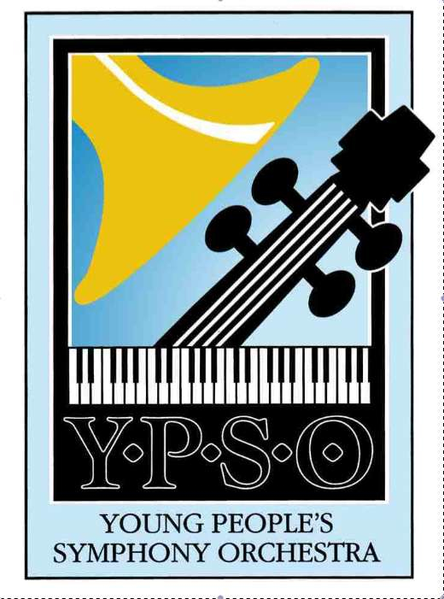

**Support YPSO for the 2018-2019 Season**

**\*\*\* Advertise Your Business in YPSO’s Concert Programs! \*\*\***

Young People’s Symphony Orchestra (YPSO) is the oldest youth orchestra in California and the second oldest in the nation. Founded in 1936, it has inspired and educated generations of musicians and tens of thousands of audience members.

YPSO provides an unsurpassed orchestral training program for committed musicians between the ages of 12 and 18. Under the guidance of conductor and Music Director David Ramadanoff, currently celebrating his 30th season with the orchestra in the 2018-19 season, 85 young musicians expand their musical experience through rehearsal and performances of a wide range of symphonic repertoire. Members come from throughout the Bay Area: 46% from Alameda County, 30% from Contra Costa County, 9% from Marin County, 4% from San Francisco, 4% from Napa, 4% from Solano, and 1% from San Mateo counties.

**300 people will see your ad in our program books at each concert. The 2018-19 Season’s Four Concerts:**

**Fall Concert**

Saturday, November 3, 2018 at 8:00 P.M.  
First Congregational Church of Berkeley, 2345 Channing Way, Berkeley, CA 94704

**Winter Concert**

Saturday, February 2, 2019 at 8:00 P.M.

First Congregational Church of Berkeley, 2345 Channing Way, Berkeley, CA 94704

**Spring Concert**

Saturday, April 27, 2019 at 8:00 P.M.

First Congregational Church of Berkeley, 2345 Channing Way, Berkeley, CA 94704

**Pops Concert**

Sunday, June 9, 2019 at 3:00 P.M.

Greek Orthodox Cathedral of the Ascension

4700 Lincoln Ave, Oakland, CA 94602

Tickets are available at the door or in advance: 510-849-9776 or, at [www.brownpapertickets.com](http://www.brownpapertickets.com).



**2018-19 Concert Program Ad Business Order Form**

Business Name_________________________________________________________________

Business Address_______________________________________________________________

Business Phone_________________________________________________________________

**Ad size (please check size *and* circle amount)**

Sizes inches, width x height Full Season (4 Concerts / 4 programs)

1/3 (horiz.) 4.25 2.1667 $100 **business card horizontal**

1/3 (vert.) 2.00 4.5833 $100 **business card vertical**

Per Program Full Season (4 Concerts / 4 programs)

1/2 (horiz.) 4.25 3.375 $50 $225

2/3 (vert.) 4.25 4.5833 $75 $375

Full Page 4.25 7 $100 $450

Inside Front or Back Cover (Full Page) $150 $675

Outside Back Cover (Full Page) $175 $800

**Artwork (please check)**

Camera-ready art is attached

Digitally reproduced art has been emailed to [keith.gleason@ypsomusic.org](mailto:keith.gleason@ypsomusic.org)

**Payment**

Check # ________ Amount _________ Date __________

Student seller’s Name________________________________________

Student seller’s Phone_________________________ Email______________________________

**Program Ad Deadlines:**

**FULL SEASON: October 24, 2018**

**Fall Concert: October 24, 2018**

**Winter Concert: January 21, 2019**

**Spring Concert: April 15, 2019**

**Pops Concert: May 28, 2019**

**A completed order form and payment must accompany EACH AD.**

**Order forms may be copied; for additional forms and questions, contact:**

[**ypso@ypsomusic.org**](mailto:ypso@ypsomusic.org) **or** [**keith.gleason@ypsomusic.org**](keith.gleason@ypsomusic.org)

Return form with payment to: YPSO, 2600 Tenth St., Suite 413, Berkeley, CA. 94710

**Ad Sizes and Specs**

Sizes (in inches, width x height): (notes &/or size in picas)

Full page 4.25 7.00 (no bleeds)

2/3 (vert.) 4.25 4.5833 (25p.6 x 27p.6)

1/3 (horiz.) 4.25 2.1667 (25p.6 x 13p.0) business card horizontal

1/3 (vert.) 2.00 4.5833 (12p.0 x 27p.6) business card vertical

½ (horiz.) 4.25 3.375 (25p.6 x 20p.3)

Colors:

Program is black and white only.

Text and cover both use 120--‐line screen

File formats: (PC or Mac PDFs; otherwise Mac only):

Press--‐optimized PDF preferred (no screen resolution or “printer” resolution)

Adobe Illustrator (through cs4), fonts converted to outlines

InDesign (through cs4), fonts as outlines; links included (please package)

No Microsoft Word, Publisher or Excel files.

Hard copy can be scanned, or plain text (email) can be typeset by us at extra cost.

File formats for “message” ads (1/6 page square), which we will typeset:

In body of email (to address below); Word or plain text files (email) also accepted.

Delivery method:

E-mail files under 10 Mb to: [keith.gleason@ypsomusic.org](mailto:keith.gleason@ypsomusic.org)

Send files on CD or DVD to YPSO, 2600 Tenth Street, Suite 413, Berkeley, CA 94710.

Include a PDF proof for reference (even if supplying native files).

Other:

Ads must have borders and must be exact size.

All fonts and linked files must be included. No pc-only files (except PDFs).

Placed graphics must be grayscale (only). GIF or WMF or low resolution files.

Scanned photos must be 200 ppi at final size; scanned line art must be 1200 ppi.

Please see Advertising Schedule for deadlines. Please supply a working email address so that we can send PDF proofs of ads for approval.